HISTORY OFTHERMODYNAMICS

1.1 Preliminary semantics
We introduce here classical thermodynamics. The word “thermo-dynamic,” used first by
Thomson (later Lord Kelvin),1 has Greek origin, and is translated2 as the combination of
• θ´ǫρμη, therme: heat, and
• δ´υναμις, dynamis: power.
An image of Thomson and his 1849 first use of the word is given in Fig. 1.1
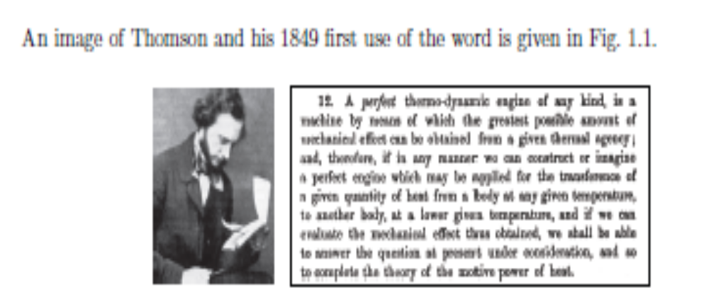
Figure 1.1: William Thomson (Lord Kelvin) (1824-1907), Ulster-born Scottish scientist; image
from http://www-history.mcs.st-and.ac.uk/_history/Biographies/Thomson.html
and image giving the first use of “thermo-dynamic” extracted from his 1849 work.

The modifier “classical” is used to connote a description in which quantum mechanical effects, the molecular nature of matter, and the statistical nature of molecular behavior are not considered in any detail. These effects will not be completely ignored; however, they will be lumped into simple averaged models which are valid on the macroscale. As an example, for ordinary gases, our classical thermodynamics will be valid for systems whose characteristic length scale is larger than the mean free path between molecular collisions. For air at atmospheric density, this about 0.1 μm (1 μm = 10−6 m).

Additionally, “classical” also connotes a description in which the effects of finite time dependency are ignored. In this sense, thermodynamics resembles the field of statics from Newtonian mechanics. Recall Newton’s second law of motion, m d²x/dt² = ΣF, where m is the mass, x is the position vector, t is time, and F is the force vector. In the statics limit where ΣF = 0, inertial effects are ignored, as is time-dependency. Now a Newtonian would consider dynamics to imply motion, and so would consider thermodynamics to imply the time-dependent motion of heat. So a Newtonian would be more inclined to call the subject of these notes “thermostatics.” However, if we return to the earlier Greek translation of dynamics as power, we are actually truer to the classical connotation of thermodynamics. For the fundamental interplay of thermodynamics is that between so-called thermal energy (as might be thought of when considering heat) and mechanical energy (as might be thought of when considering power, a work rate). More formally, adopting the language of BS (p. 13), we will take the definition
• thermodynamics: the science that deals with heat and work and those properties of
matter that relate to heat and work.

One of the main goals of these notes will be to formalize the relationship between heat, work, and energy. We close this section by noting that the concept of energy has evolved through time, but has ancient origins. The word itself had its first recorded use by Aristotle. His portrait, along with an image of the relevant section of an 1818 translation of his work, is depicted in Figs. 1.2. In the Greek, the word , ǫν´ǫργǫια, “energeia,” connotes activity or operation. While the word was known to Aristotle, its modern usage was not; it was the English polymath Thomas Young who first used the word “energy,” consistent with any sort modern usage, in this case kinetic energy.4 A portrait of Young and an image of his text defining energy, in actuality kinetic energy, in modern terms are shown in Fig. 1.3.

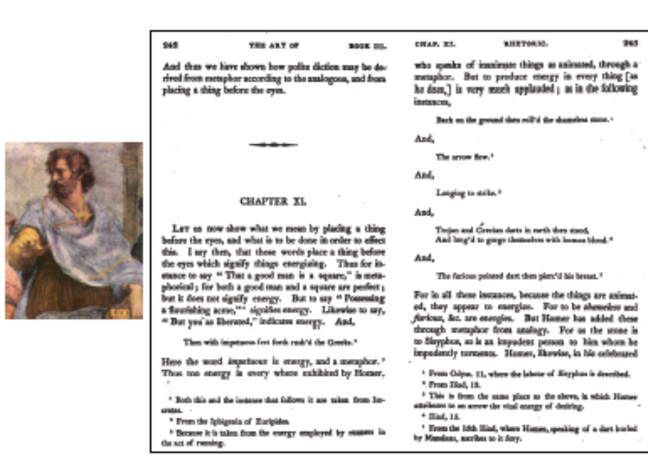
Figure 1.2: Aristotle (384 BC-322 BC), Greek philosopher who gives the first recorded use
of the word “energy” and whose method of logic permeates classical thermodynamics; image
from http://www-history.mcs.st-and.ac.uk/_history/Biographies/Aristotle.html
and an image of Aristotle’s usage of the word “energy” from his Nicomachean Ethics.

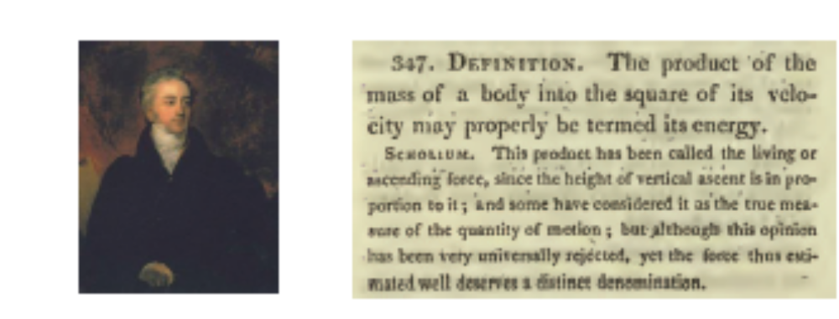
Figure 1.3: Thomas Young (1773-1829), English natural philosopher; image from
http://en.wikipedia.org/wiki/Thomas Young (scientist), and a reproduction of his
more modern 1807 definition of (kinetic) energy.

Finally, though she did not use the word “energy,” the notion of what is now known as kinetic energy being related to the square of velocity was first advanced by du Chˆatelet, pictured in Fig. 1.4.

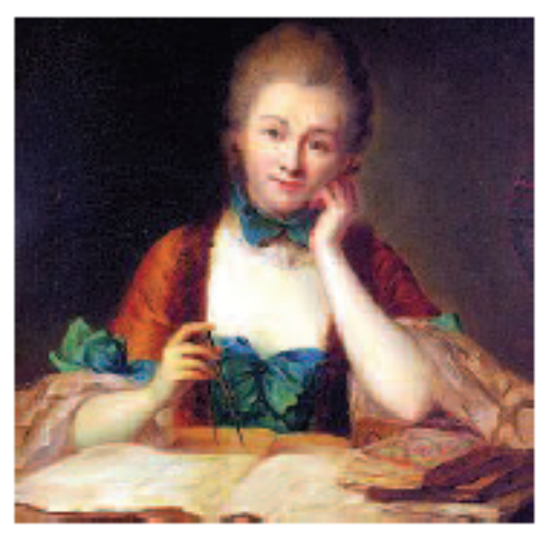

Figure 1.4: Gabrielle ´ Emilie Le Tonnelier de Breteuil, marquise du Chˆatelet (1706-1749),
French physicist; image from http://en.wikipedia.org/wiki/Emilie du Chatelet.

1.2 Historical milestones

Thermodynamics has a long history; unfortunately, it was not blessed with the crispness of
development that mechanics realized with Newton. In fact, its growth is filled with false steps, errors, and debate which continues to this day. Truesdell6 and M¨uller78 summarize the development in their idiosyncratic histories. Some of the milestones of its development are given here:

• first century AD: Hero of Alexandria documents many early thermal engines.
• 1593: Galileo develops water thermometer.
• 1650: Otto von Guericke designs and builds the first vacuum pump.
• 1662: Robert Boyle develops his law for isothermal ideal gases.
• 1679: Denis Papin develops his steam digester, forerunner to the steam engine.
• 1698: Thomas Savery patents an early steam engine.
• 1710: Thomas Newcomen creates a more practical steam engine.
• 1760s: Joseph Black develops calorimetry.
• 1780s: James Watt improves the steam engine.
• 1798: Benjamin Thompson (Count Rumford) considers the mechanical equivalent of
heat from cannon boring experiments.
• 1824: Nicolas L`eonard Sadi Carnot discusses idealized heat engines.
• 1840: Germain Henri Hess considers an early version of the first law of thermodynamics
for work-free chemical reactions.
• 1840s: Julius Robert von Mayer relates heat and work.
• 1840s: James Prescott Joule relates heat and work.
• 1847: Hermann von Helmholtz publishes his theory of energy conservation.
• 1848: William Thomson (Lord Kelvin) postulates an absolute zero of temperature.
• 1850: Rudolf Julius Emanuel Clausius formalizes the second law of thermodynamics.
• 1865: Clausius introduces the concept of entropy.
• 1871: James Clerk Maxwell develops the Maxwell relations.
• 1870s: Josiah Willard Gibbs further formalizes mathematical thermodynamics.
• 1870s: Maxwell and Ludwig Boltzmann develop statistical thermodynamics.
• 1889: Gibbs develops statistical mechanics, giving underlying foundations for classical
and statistical thermodynamics.
Much development continued in the twentieth century, with pioneering work by Nobel laureates:
• Jacobus Henricus van’t Hoff (1901),
• Johannes van der Waals (1910),
• Heike Kamerlingh Onnes (1913),
• Max Planck (1918),
• Walther Nernst (1920),
• Albert Einstein (1921),
• Erwin Schr¨odinger (1933),
• Enrico Fermi (1938),
• Percy Bridgman (1946),
• Lars Onsager (1968),
• Ilya Prigogine (1977), and
• Kenneth Wilson (1982).

Note that Sir Isaac Newton also considered the subject matter of thermodynamics. Much of his work is concerned with energy; however, his theories are most appropriate only for mechanical energy. The notion that thermal energy existed and that it could be equivalent to mechanical energy was not part of Newtonian mechanics. Note however, that temperature was known to Newton, as was Boyle’s law. However, when he tried to apply his theories to problems of thermodynamics, such as calculation of the speed of sound in air, they notably failed. The reason for the failure required consideration of the yet-to-be-developed second law of thermodynamics.

1.3 Philosophy of science note

As with science in general, thermodynamics is based on empirical observation. Moreover, it is important that those observations be repeatable. A few postulates, also known as axioms, will serve as the foundation of our science. Following Occam’s razor,9 we shall seek as few axioms as possible to describe this behavior. We will supplement these axioms with some necessary definitions to describe nature. Then we shall use our reason to deduce from the axioms and definitions certain theorems of engineering relevance.

This approach, which has its foundations in Aristotelian methods, is not unlike the approach taken by Euclid to geometry, Aquinas to theology, or Newton to mechanics. A depiction of Euclid is given in Fig. 1.5. Consider for example that Euclid defined certain entities such as points, lines, and planes, then adopted certain axioms such as parallel lines do not meet at infinity, and went on to prove a variety of theorems. Classical thermodynamics follows the same approach. Concepts such as system and process are defined, and axioms, known as the laws of thermodynamics, are proposed in such a way that the minimum amount of theory is able to explain the maximum amount of data.
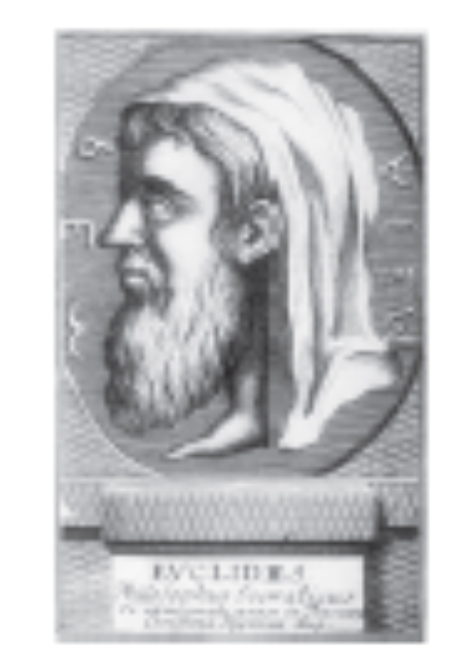

Figure 1.5: Euclid of Alexandria (_ 325 BC- _265 BC), Greek mathematician whose rational exposition of geometry formed a model for how to present classical thermodynamics; imagefrom http://www-history.mcs.st-and.ac.uk/_history/Biographies/Euclid.html.
Now, in some sense science can never be formally proved; it can only be disproved. We retain our axioms as long as they are useful. When faced with empirical facts that unambiguously contradict our axioms, we are required to throw away our axioms and develop
new ones. For example, in physics, the ichelson-Morely experiment forced Einstein to abandon the axioms of Euclid, Newton, and Clausius for his theory of general relativity. It turns out that we can still use these axioms, as long as we are considering problems in which the speed of our reference frame is far less than the speed of light. In an example from biology that is the topic of a popular science book,10 it was believed that all swans were white. This working hypothesis was perfectly acceptable until 1697, when a black swan was discovered in Australia. Thus the “theory” (though it is not a highly profound theory) that all swans were white was unambiguously discredited. It will be briefly seen in this course that non-classical thermodynamics actually has a deep relation to probability and statistics and information, a topic which transcends thermodynamics.

1.4 Some practical applications

It turns out that the classical approach to thermodynamics has had success in guiding the engineering of devices. People have been building mechanical devices based on thermal energy inputs for centuries, without the benefit of a cleanly enunciated theory. Famously, Hero of Alexandria, perhaps the first recognized thermal engineer, documented a variety of devices. These include an early steam engine,11 the æolipile, a device to use fire to open doors, pumps, and many others. Hero and a nineteenth century rendition of his steam engine are shown in Fig. 1.6. While Hero’s contributions are a matter of some speculation inspired by ancient artistry, the much later works of Denis Papin (1647-1712) are more certain. Papin invented the so-called steam digester, which anticipated both the pressure cooker and the steam engine. The device 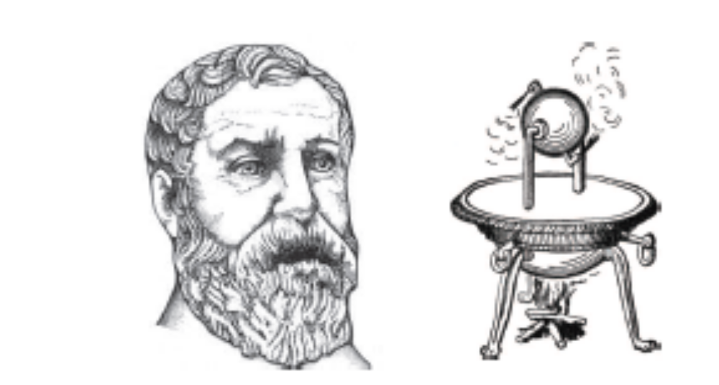
Figure 1.6: Hero of Alexandria (10-70 AD), Greek engineer and mathematician who devised
some early ways to convert thermal energy into mechanical energy, and his æolipile; images
from http://en.wikipedia.org/wiki/Hero of Alexandria.
used steam power to lift a weight. Depictions of Papin and his device are found in in Fig. 1.7. Significant improvements were led by JamesWatt (1736-1819).
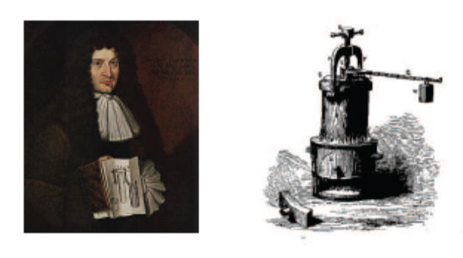

Figure 1.7: French-born inventor Denis Papin (1647-1712) and his steam digester; images
from http://en.wikipedia.org/wiki/Denis Papin.
of Scotland. An image of Watt and one of his engines is shown in Fig. 1.8.
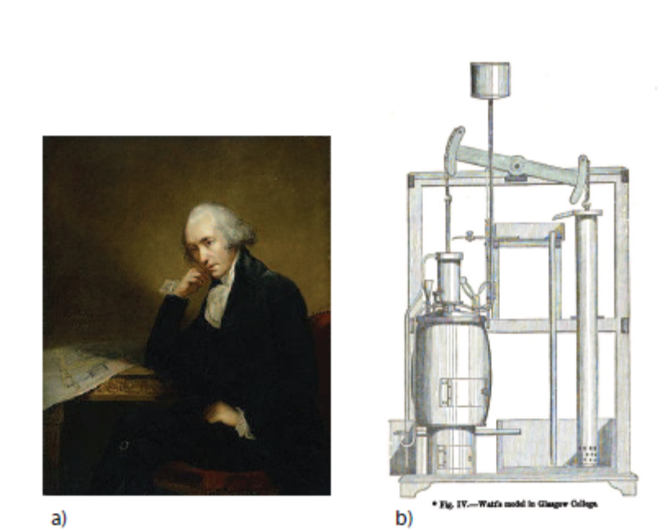
Figure 1.8: a) Scottish engineer James Watt (1736-1819); image from
http://en.wikipedia.org/wiki/James Watt, b) Sketch of one of Watt’s steam engines;
image from W. J. M. Rankine, 1859, A Manual of the Steam Engine and Other Prime
Movers, First Edition, Griffin, London.

These engines were adopted for transportation. In 1807, the American engineer Robert Fulton (1765-1815) was the first to use steam power in a commercial nautical vessel, the Clermont, which was powered by a Boulton and Watt steam engine. Soon after, in 1811 in Scotland, the first European commercial steam vessel, the Comet, embarked. We have a sketch of the Comet and its steam power plant in Fig. 1.9. On land, steam power soon enabled efficient rail
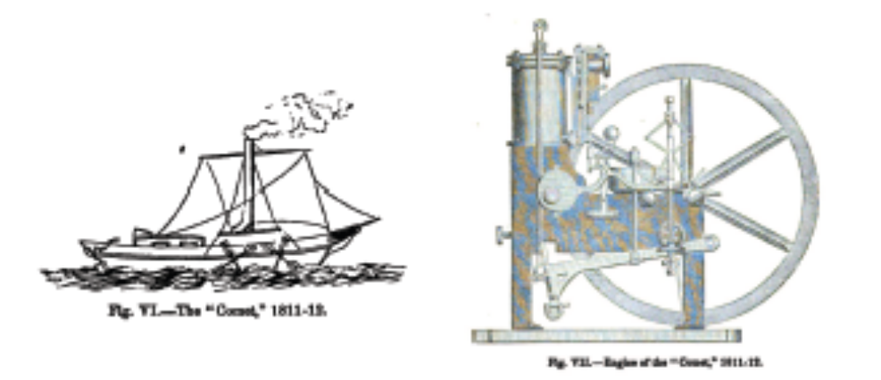

Figure 1.9: Sketch of the Comet and its steam engine; image from W. J. M. Rankine, 1859,
A Manual of the Steam Engine and Other Prime Movers, First Edition, Griffin, London.

transportation. A famous early steam locomotive was the English engineer Robert Stephenson’s (1803-1859) Rocket, sketched in Fig. 1.10.
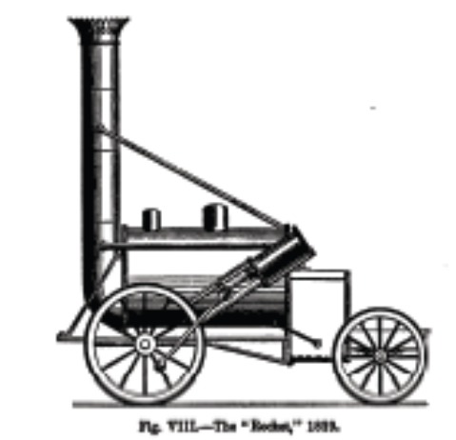

Figure 1.10: Sketch of the Rocket; image from W. J. M. Rankine, 1859, A Manual of the
Steam Engine and Other Prime Movers, First Edition, Griffin, London.

The effect of steam by engineers, on the development of the world remains remarkable. While it is difficult to quantify historical pronouncements, it is likely that the effect on the world was even more profound than the introduction of networked computers in the late twentieth century. In short, steam power was the linchpin for the industrial revolution. Steam power replaced animal power as a prime mover throughout much of the world and, where implemented, enabled rapid development of broad economic segments: mining, manufacturing, land and sea transportation, among others. Large scale population movements ensued as opportunities in urban manufacturing centers made industrial work more appealing than agricultural work. Certainly, changes precipitated by the advent of steam power were contributing factors in widespread social unrest in the nineteenth century, ranging from labor strife to war between nation states.The text of BS has an introduction to some more modern devices, listed here:

• simple steam power plant,
• fuel cells,
• vapor-compression refrigeration cycle,
• air separation plant,
• the gas turbine, and
• the chemical rocket engine.

As an example, the main power plant of the University of Notre Dame, depicted in Fig. 1.11, is based on a steam power cycle which will be a topic of study in this course. Additionally, one might consider the following topics to have thermodynamic relevance:

• gasoline and Diesel engines,
• the weather,
• cooking,
• heating, refrigeration, and air conditioning (HVAC), or
• materials processing (metals, polymers, etc.).

